**Quick Facts about NM GRADS**

Since its inception in 1989, New Mexico Graduation, Reality, And Dual-role Skills (GRADS) instructional program has impacted the educational and financial success and family health of expectant and parenting teens of New Mexico. The primary focus of NM GRADS is to provide in-school programs that address the needs of teenage families (which helps schools comply with Title IX Educational Amendment Act of 1972). NM GRADS is vital in keeping teen parents in school, promoting the neonatal and teen parent health, preparing teens to be financially independent, preventing repeat pregnancies and supporting school-age ready children of teen parents.

NM GRADS is funded by the NM Legislature and overseen by the NM Public Education Department. NM GRADS has experienced significant funding reductions over the last seven years, however we continue to reach hundreds of teens and their families, having significant impact on the teens’ graduation rate, repeat pregnancies and neonatal health.

**Positive Impacts of NM GRADS in the 2015-16 School Year**

(impacting 531 teen parents, both male and female)

**Graduation Rate for Teen Mothers**1 **Repeat Births for Teen Parents**2

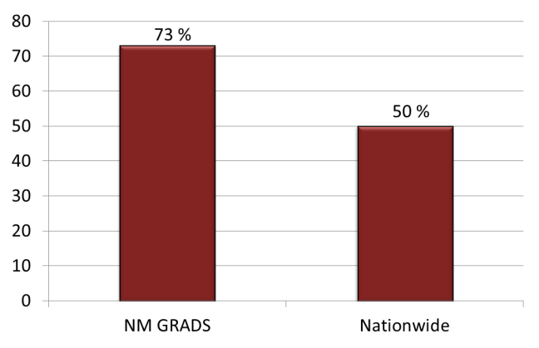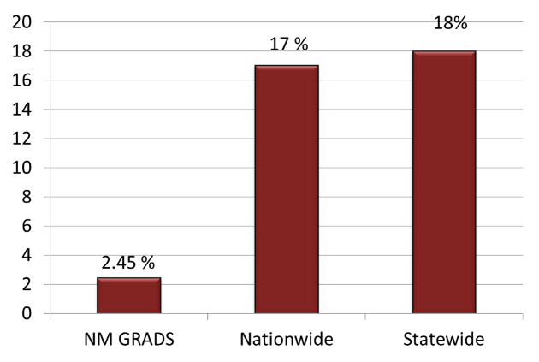

**Low Birth Weight Babies**2

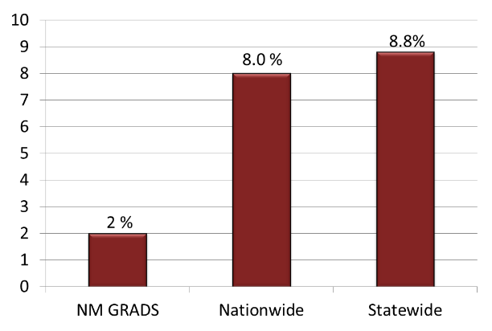

1.Diploma Attainment Among Teen Mothers 2010; Child Trends, 2 Kids Count 2015

(Please turn over for additional facts)

* NM GRADS is a teen parenting program for elective credit in public, charter and alternative school settings which utilizes certified teaching professionals to present the curriculum.
* NM GRADS helps its students learn how to balance work and family roles.
* NM GRADS helps prepare its students for work and careers to gain economic independence.
* NM GRADS focuses on recruiting and retaining school age dropouts.
* NM GRADS provides partial funding for on-site child development centers. This removes a *huge* barrier for the teen parents that facilitates teen school attendance, thus increasing graduation rates, and allows the teens to be near their child for supervised parenting instruction and the development of healthy secure relationships.
* NM GRADS focuses on healthy choices for teens and their children which include:
  1. delaying second pregnancies (GRADS curriculum includes approved comprehensive sex education information),
  2. encouraging prenatal/maternal care to avoid low birth weight babies,
  3. promoting safe and healthy family relationships.
* NM GRADS teachers worked with 531 teen parents in 28 GRADS sites across NM during the 2015-16 school year.
* NM GRADS recruited 92 dropouts back to school (generating approximately $371,473 for school districts). Since 1989, over ***3,950*** teen parents have been recruited back to school.

Since 1989, over 16,950 teen parents have been impacted by the GRADS program.

NM GRADS would like to thank you for all your past support! We invite you to visit any of our GRADS sites across the state. We have enclosed a listing of all NM GRADS sites with contact information.

To obtain additional information regarding NM GRADS, visit:

* Our website, [www.nmgrads.org](http://www.nmgrads.org)
* Our blog, nmgrads.wordpress.org
* Follow us on [Facebook](http://www.facebook.com/pages/New-Mexico-Graduation-Reality-Dual-Role-Skills-NM-Grads/120524774887) and [Twitter](http://twitter.com/nmgrads)!

Contact us at NM GRADS, 575-835-1785, nmgrads@nmgrads.org